Grazioso Salvare Animal Rescue Dashboard
Project Two README | Luca Formento | CS-340 Client/Server Development

Project Overview
This project is a full stack web application dashboard built for Grazioso Salvare, an international rescue animal training company. Grazioso Salvare uses outcome data from five animal shelters in the Austin, Texas region to identify dogs that are good candidates for search and rescue training. The dashboard sits on top of that data and lets a non technical user at Grazioso Salvare filter the shelter records down to the dogs that match a specific rescue profile without writing a single query.
The application follows the Model View Controller pattern. MongoDB holds the model, a Python CRUD module acts as the interface layer between the application and the database, and the Dash framework supplies both the view (the widgets the user sees) and the controller (the callbacks that wire those widgets together). Everything runs from a single Jupyter notebook, ProjectTwoDashboard.ipynb, which imports the CRUD module developed in Project One.

Required Functionality
The dashboard delivers four pieces of functionality that work together. First, a set of interactive radio buttons lets the user choose a rescue type. Second, an interactive data table displays the records returned for that rescue type. Third, a pie chart summarizes the breed distribution of whatever the table is currently showing. Fourth, a geolocation map plots the exact shelter location of the animal selected in the table.
Selecting a radio button fires a MongoDB query through the CRUD module, and the returned documents repopulate the data table. Because the pie chart and the map both listen to the table rather than to the radio buttons directly, they update automatically whenever the table changes, and they also respond to any sorting, native filtering, or row selection the user performs inside the table itself. The Reset option returns every widget to its original unfiltered state showing all animals in the collection.
The filtering logic implements the Rescue Type and Preferred Dog Breeds table from the Dashboard Specifications Document. Water rescue returns intact female dogs between 26 and 156 weeks old whose breed is Labrador Retriever Mix, Chesapeake Bay Retriever, or Newfoundland. Mountain or wilderness rescue returns intact male dogs between 26 and 156 weeks old whose breed is German Shepherd, Alaskan Malamute, Old English Sheepdog, Siberian Husky, or Rottweiler. Disaster or individual tracking returns intact male dogs between 20 and 300 weeks old whose breed is Doberman Pinscher, German Shepherd, Golden Retriever, Bloodhound, or Rottweiler.
Every screenshot below includes the Grazioso Salvare logo and my unique identifier, which reads Created by Luca Formento and sits directly under the dashboard title.
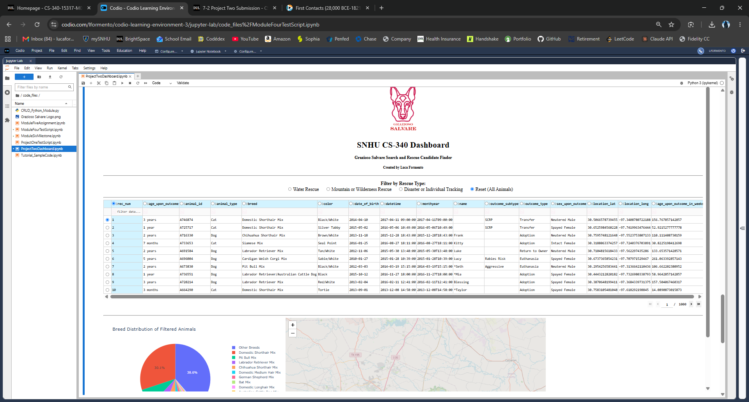
Figure 1. Starting state of the dashboard showing the logo, unique identifier, radio button filters, the unfiltered interactive data table, the breed distribution pie chart, and the geolocation map.
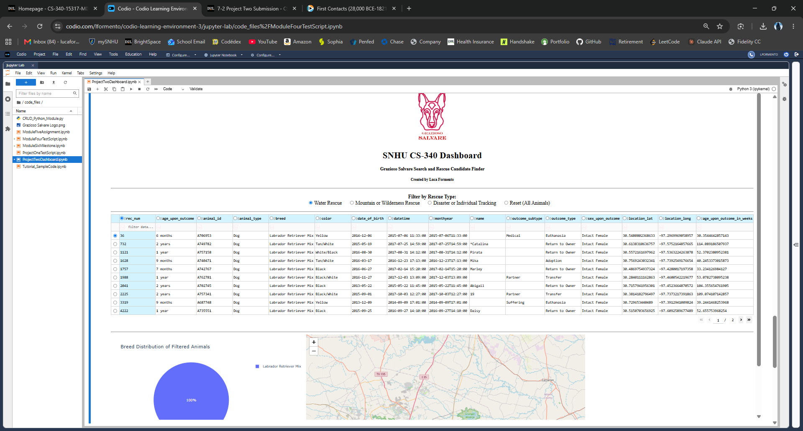
Figure 2. Water Rescue filter applied. The table, pie chart, and map all update to show only intact female dogs between 26 and 156 weeks of the three preferred water rescue breeds.
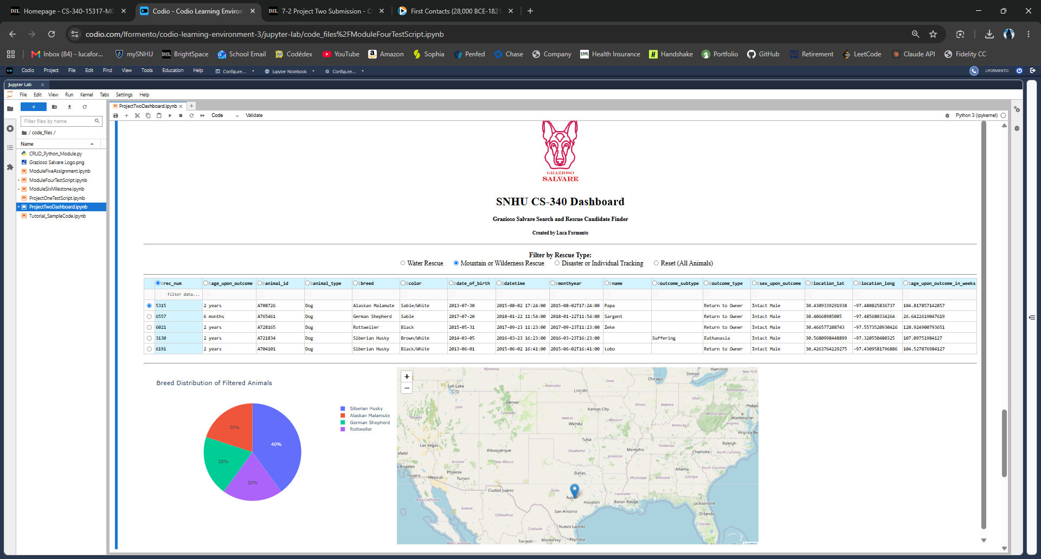
Figure 3. Mountain or Wilderness Rescue filter applied. The widgets update to show intact male dogs between 26 and 156 weeks of the five preferred mountain rescue breeds.
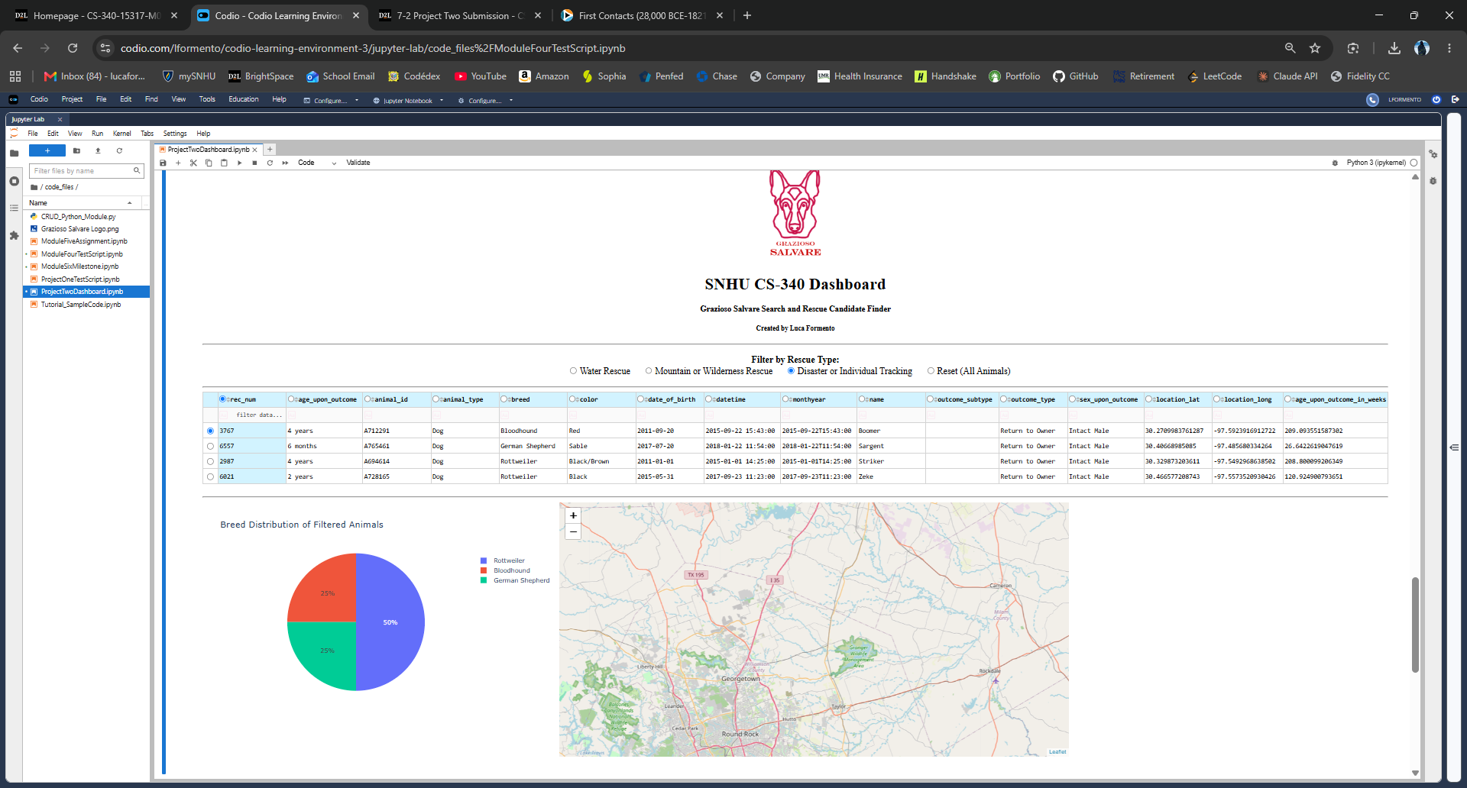
Figure 4. Disaster or Individual Tracking filter applied. The widgets update to show intact male dogs between 20 and 300 weeks of the five preferred tracking breeds.
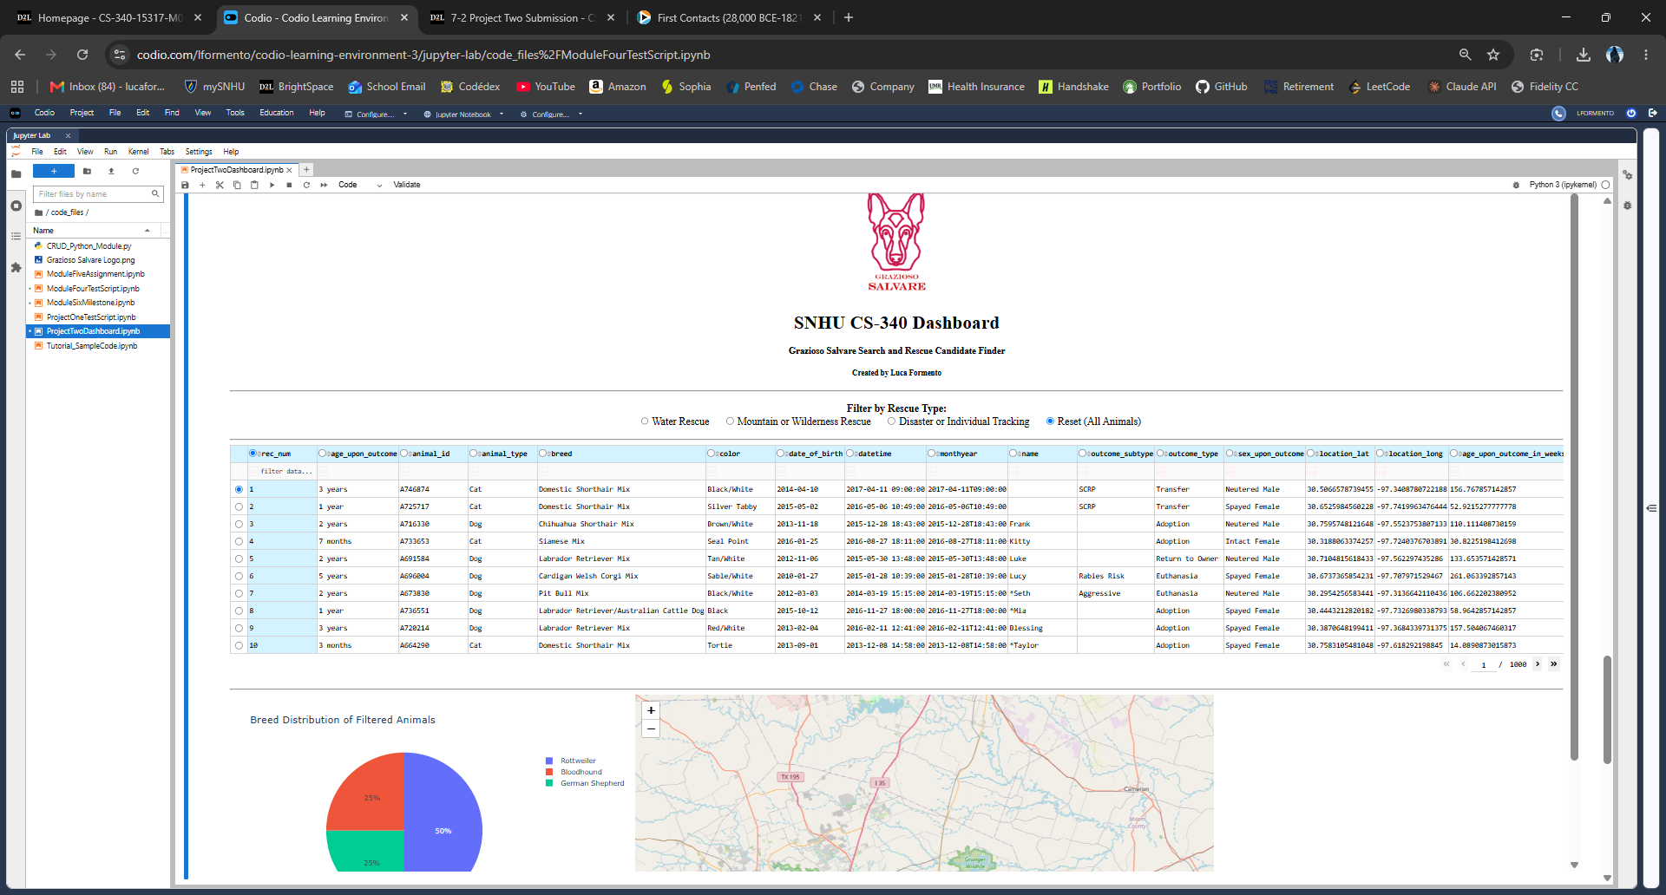
Figure 5. Reset applied. All widgets return to their original unfiltered state showing the complete Austin Animal Center Outcomes data set.

Tools Used and Rationale
MongoDB serves as the model component of this application. I picked it partly because the project specified it, but working with it made the reasoning obvious. The Austin Animal Center Outcomes data set is a flat, document friendly export where each animal is a self contained record, which maps directly onto MongoDB's document model with no schema design or table joins required. MongoDB is also schema flexible, so the three columns the client added to this data set, location_lat, location_long, and age_upon_outcome_in_weeks, needed no migration at all.
What makes MongoDB especially useful for interfacing with Python is that its documents are essentially JSON, and the PyMongo driver hands them back as native Python dictionaries. That means a query document, a returned record, and a Python dictionary are all the same shape, so there is no object relational mapping layer to write or maintain. From there, pandas can turn a list of those dictionaries into a DataFrame with a single call, and Dash can consume that DataFrame directly. Indexing also matters here. I created indexes on breed and a compound index on breed and outcome_type during the Module Three milestone, which keeps the rescue filter queries fast even as the collection grows.
Dash provides the view and the controller. On the view side, Dash builds the entire user interface out of Python objects, so components like html.Div, dcc.RadioItems, dash_table.DataTable, and dash_leaflet.Map are declared in Python and rendered as React components in the browser. That let me build a browser based dashboard without writing any HTML, CSS, or JavaScript. On the controller side, Dash uses a reactive callback system where each function is decorated with the outputs it produces and the inputs it depends on. When an input changes, Dash reruns that function and pushes the new output to the browser. This is what chains the widgets together: the radio buttons feed the table, and the table feeds both the pie chart and the map, so a single click cascades through the whole interface.
Plotly Express handles the pie chart, since it ships with Dash and turns a grouped DataFrame into a chart in one line. Dash Leaflet handles the geolocation chart because it wraps the Leaflet mapping library as Dash components, which lets me drop a marker with a tooltip and a popup using the same Python syntax as the rest of the layout. Pandas sits in between the database and the widgets to reshape query results. PyMongo is the official Python driver that the CRUD module is built on. Jupyter Dash allows the Dash server to run inline inside a Jupyter notebook, which is how the application is deployed in the Codio environment.

Resources and Software Used
MongoDB documentation is available at https://www.mongodb.com/docs. The PyMongo driver documentation is at https://pymongo.readthedocs.io. The Dash framework and Dash Core Components documentation is at https://dash.plotly.com. Dash Leaflet documentation is at https://www.dash-leaflet.com. Plotly Express documentation is at https://plotly.com/python/plotly-express. Pandas documentation is at https://pandas.pydata.org/docs. The PEP 8 style guide referenced for code formatting is at https://peps.python.org/pep-0008. The data set is Austin Animal Center. (2020). Austin Animal Center Outcomes [Data set]. City of Austin, Texas Open Data Portal, available at https://doi.org/10.26000/025.000001. Development, testing, and deployment were all done in the Codio virtual lab environment using JupyterLab and the Codio Terminal.

Steps Taken to Complete the Project
I started by importing the Austin Animal Center Outcomes CSV into MongoDB from the Codio Terminal using mongoimport, which created the aac database and the animals collection with roughly ten thousand documents. I verified the import in mongosh with a count and a few sample find queries to confirm the field names and data types, particularly that age_upon_outcome_in_weeks came in as a numeric type rather than a string.
Next I set up authentication. I created a dedicated aacuser account in the admin database with the readWrite role scoped to the aac database, which follows the principle of least privilege rather than connecting the application as an administrative user. I then added indexes on breed and a compound index on breed and outcome_type to support the filter queries.
With the database in place I wrote the CRUD Python module, CRUD_Python_Module.py, which defines the AnimalShelter class. The constructor accepts a username and password and builds an authenticated PyMongo connection to the aac database. The class exposes four methods: create wraps insert_one and returns a boolean, read wraps find and returns a list of documents, update wraps update_many with a $set operator and returns the modified count, and delete wraps delete_many and returns the removed count. Each method validates its parameters and wraps the database call in exception handling so a bad query surfaces a readable message instead of crashing the dashboard.
I then built the dashboard in layers. I started with the layout, adding the Grazioso Salvare logo through base64 encoding, the dashboard title, and my unique identifier. I added the interactive data table next and populated it with an unfiltered read, then configured native filtering, multi column sorting, pagination at ten rows per page, single column selection, and single row selection so the client can navigate ten thousand records comfortably.
After the table worked I wrote the three filter query functions. Each one returns a MongoDB query document built from the breed, sex, and age criteria in the Rescue Type and Preferred Dog Breeds table, and each one is executed through the CRUD module read method so that all filtering happens in the database rather than in pandas. I mapped those functions to radio button values in a dictionary, which keeps the callback short and makes adding a fourth rescue type a one line change.
I wired the radio buttons to the data table through a callback that returns new data, new columns, and a reset row selection. Then I added the two charts. The pie chart groups the currently displayed records by breed and collapses everything past the top ten into an Other Breeds slice so the chart stays legible on the unfiltered view. The geolocation map centers on Austin and drops a marker at the latitude and longitude of the selected row, with the breed in the tooltip and the animal name in the popup. Both charts take derived_virtual_data from the table as their input rather than the radio buttons, which is the key design decision that makes them respond to filtering, sorting, and native table filtering all at once.
Finally I tested and deployed the dashboard by running the notebook and stepping through each rescue filter, confirming the record counts changed, the pie chart redrew, the map marker moved, and the Reset option restored the full data set. I captured the five screenshots included in this document as proof of that testing.

Challenges and How They Were Overcome
The first problem I ran into was in the Codio Terminal rather than the code. Commands typed before mongosh finished loading were getting swallowed, so my user creation and import commands would silently do nothing and I would waste time debugging a database that was actually empty. Once I figured out what was happening, the fix was just discipline: run one command, wait for the prompt to come back, then run the next. I also had to remember that mongoimport runs from the bash prompt while the database commands run inside mongosh, which is easy to mix up.
The second challenge was authentication failures when the dashboard tried to connect. The cause was that aacuser had been created in the wrong database context. I resolved it by dropping the user and recreating it in the admin database with the readWrite role explicitly scoped to aac, and by making sure the connection string in the CRUD module specified authSource=admin. Without that parameter PyMongo authenticates against the target database instead of admin and the connection is rejected.
The third challenge was a crash in the data table on startup. MongoDB returns an _id field of type ObjectId, which is not JSON serializable, so the DataTable failed as soon as it tried to render. Dropping the _id column from the DataFrame immediately after every read fixed it. I put that drop inside the shared helper function that builds the filtered DataFrame so it applies to the filtered queries as well as the initial load, not just once at startup.
The fourth challenge involved two callback errors that both came down to timing. The style callback threw an exception because selected_columns arrives as None before the table has rendered, and the map callback threw an IndexError because it tried to read a row from an empty DataFrame during the first render. I added guard clauses to both: the style callback returns an empty list when selected_columns is None, and the map callback returns early when viewData is None or the DataFrame is empty. That pattern of checking for None and empty data before touching a row is something I applied everywhere in the callbacks after hitting it twice.
The last challenge was a design one rather than a bug. My first version of the pie chart was unreadable because the unfiltered data set contains hundreds of distinct breeds and the chart rendered a slice for every one of them. I fixed it by grouping the top ten breeds by count and rolling the remainder into a single Other Breeds slice, which keeps the chart informative on the full data set and still shows the complete breakdown on the much smaller filtered views.

Reproducing the Project
To reproduce this project, start a Codio session for the CS-340 environment and open the Terminal. Import the data set with the command mongoimport --db aac --collection animals --type csv --headerline --file aac_shelter_outcomes.csv, then launch mongosh and create the application user by switching to the admin database and running db.createUser with the user aacuser, the chosen password, and the readWrite role on the aac database. Add the indexes with db.animals.createIndex on breed and a compound index on breed and outcome_type.
Place CRUD_Python_Module.py, ProjectTwoDashboard.ipynb, and Grazioso Salvare Logo.png in the same working directory so the notebook can import the module and read the logo file. Open the notebook in JupyterLab, update the username and password variables at the top of the first cell to match the credentials created above, then run the cell. Dash starts a local server and the dashboard renders inline in the notebook output. Selecting each radio button confirms the filters, the table, the pie chart, and the map are all working.

AI Usage
I used Anthropic's Claude to help review my dashboard code structure, work through the callback errors I encountered, and refine the organization of this README. All code was run, tested, and verified by me in the Codio environment, and all screenshots are of my own working dashboard.
Anthropic. (2026). Claude (Opus 5) [Large language model]. https://claude.ai

